Module Assembly - TopCoder NodeJS API User Handle Cache Deployment Guide

Revision History
Author | Revision Number | Date
isv | 1.0 | 03/11/2014

Deployment Instructions 3
1. Organization of Submission 3
2. Application Setup 3
2.1 Configuration 3
2.2 Build Scripts Setup 3
3. Database Setup 4
4. Deployment Instructions 4
5. Starting 4
6. Verification 4
7. Resource Contact List 6

Deployment Instructions

Organization of Submission

The submission follows directory structure provided below:

tc-api

Contains the configuration, libraries, sources for TopCoder Node JS API application developed/updated in the course of this assembly. This directory replicates the application development distribution structure and includes only updated and new files.

Module Assembly - TopCoder Node JS API User Handle Cache v1.0.doc

This document which is the Deployment Guide for the Module Assembly - TopCoder NodeJS User Handle Cache assembly.

Application Setup

The submission is expected to be deployed to the following environment:

JRE 1.7
NodeJS 0.10.21
Informix DS 11.0
Git
Python 2.7.6

This assembly was developed against following SVN revision:

URL: https://github.com/cloudspokes/tc-api.git
Revision: 5abaf95a6e1640aa7d0c8f0cbdee55d2b99cba1c

Configuration

Following configuration parameter has been defined by this assembly:

Property Name | File property is stored | Example Setting
defaultUserCacheLifetime | tc-api/config.js | The timeout (in milliseconds) for expiring the entries in user handles cache. Defaults to 24 hours. The actual value may be set by USER_CACHE_EXPIRY environment variable.

Build Scripts Setup

The TopCoder NodeJS API application provides the following targets which are to be used:

- install – installs TopCoder NodeJS API application
- rebuild – rebuilds TopCoder NodeJS API application
- test – runs Mocha-based unit tests.

Database Setup

No changes to existing database schema have been made.

Deployment Instructions

- Set-up necessary infrastructure for TopCoder NodeJS API based on your environment and install TopCoder NodeJS API application. See following page for details:
  - https://github.com/cloudspokes/tc-api/wiki/_pages
- Copy the code from tc-api directory of submission into working copy cloned from Git repository
- Set-up environment variables to suit the current environment. See section 2.1 and https://github.com/cloudspokes/tc-api/wiki/Configure-Environment-Variables
- Re-build TopCoder NodeJS API application using npm rebuild command

Starting

- Install the TopCoder NodeJS API application
- Start ActionsHero server instance hosting TopCoder NodeJS API application (see Start Server chapter at page matching the current OS at https://github.com/cloudspokes/tc-api/wiki/_pages)

Verification

- Run the unit tests using command like npm test
The tests must be executed successfully.

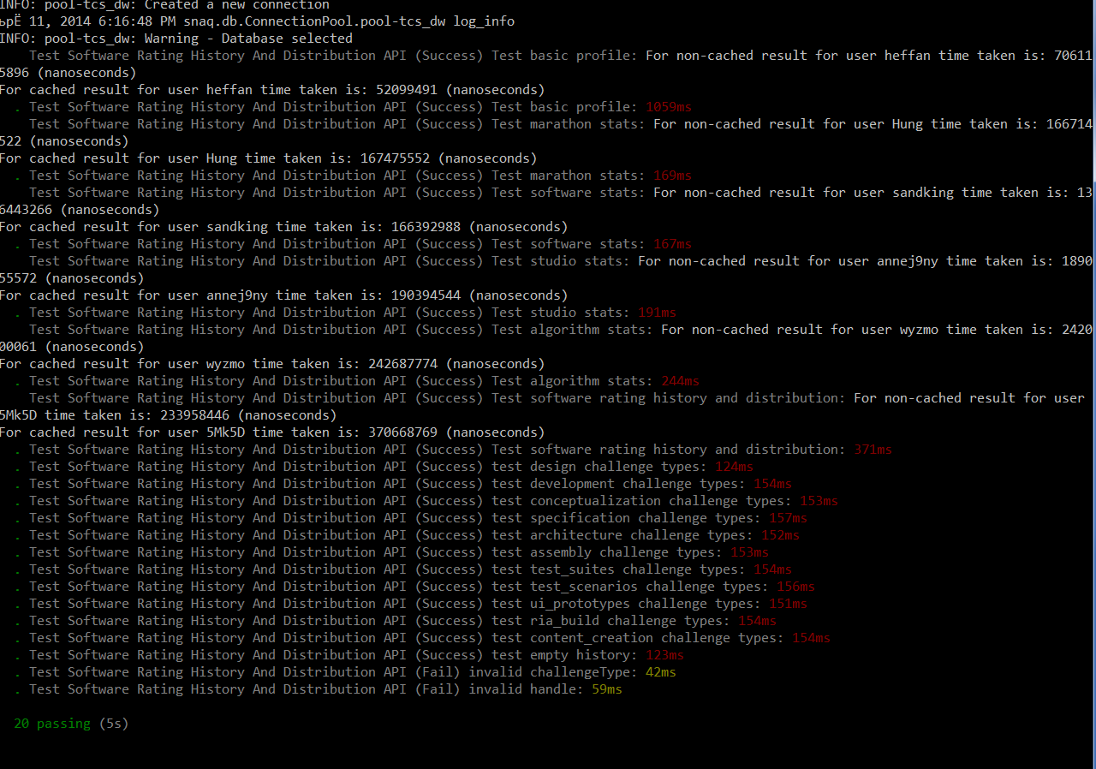

- Setup node-jslint tool using command like npm install jslint -g and check formatting for the updated code using commands like:

jslint --nomen test/test.memberStatistics.js
jslint --nomen actions/memberStatistics.js
jslint --nomen initializers/helper.js
jslint --nomen config.js

There must be no code formatting errors displayed.

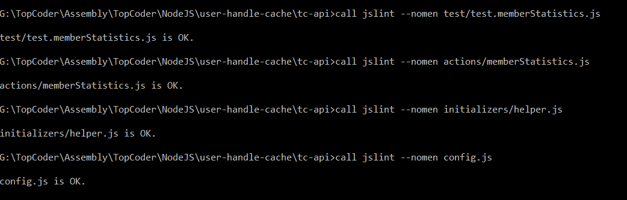

Resource Contact List

Name | Resource Email
isv

